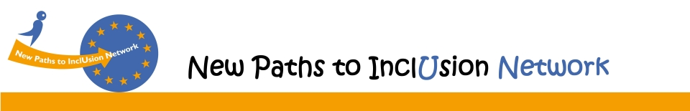
Putting citizens at the center of politics
Using person-centered planning in the transition from institutional to community-based living
European Parliament, Brussels, 19 November 2015
Name:
Surname:
Organisation:
Email:

If you do not have a badge to access the European Parliament, please provide us the following information:
Nationality:
Date of birth:
ID type: ID Card – Passport
ID Number:

Date: Signature:

Please fill this form and send it to m.birtha@inclusion-europe.org
Thank you.

