Employment, education and living in isolation

Soufiane about life and work in 2021

During the coronavirus
the hardest thing for me was not
being allowed to go to
the office to see my colleagues.

The other hard thing for me
was that I could not have
more than 2 people
come for dinner.

Also, not being able to
go to the cinema like
I did before Covid-19.

To keep myself busy
during Covid-19
I finished a lot of books
and played video games.

I also did a lot of puzzles
and I ordered things
from the Internet.

I learn how to put all my books
in order and I even re-arranged
my whole flat.

I got a lot of help from
my colleagues when I
was working from home.

I am looking forward to
the Covid-19 ending and
life going back to normal.

If we get sick it is ok,
we must just take care
of each other.

My family is doing great and
I saw them more during the
Covid-19 and it was nice.

Remember you are not alone
and you have to take life by the horns.

And say this covid-19 is
not going to stop me doing
all the things I did.

And also remember we
are all in the same boat.

Interviews with Croatian self-advocates

Interview with self-advocate Biserka Sambol

How do you spend your time in isolation?
I cook, I go to walk but I keep the distance.
I pray a lot at noon and in the evening.
I also celebrated my birthday.

At first, this situation was hard for me,
but I somehow got used to it.
I talk to family and friends
on a video call and on the telephone.
I follow the daily reports on corona virus.

Did you learn some new things during this time?
Now I am spending more time
with the people I love.
I put everything in God's hands.

Interview with self-advocate Snježana Kanjir

How do you spend your days at home during Coronavirus?
I liked to take walks
in my neighborhood,
I went for a massage and
to my hairdresser.
I always wear a mask and
gloves when I go out.
I help my mom to
clean the apartment.

Were you scared of an earthquake?
I was scared a little bit,
I ran down the stairs.
The wall in the apartment cracked.
I’m a little bored
and can’t wait to go to work.
Sometimes I talk to my friends
over the phone and see
my brother when he visits me.

Do you have a message for self-advocates?
Be careful so we can start
to work as soon as possible.

Interview with self-advocate Božidar Kobasić

What was the hardest thing for you in this corona virus crisis?

I heard about corona virus in March.

At first I didn’t know how dangerous it was.
In those first days I went on my own
for a little walk.

Only now I see how dangerous it was.

Now, I can’t wait for this coronavirus to end
so I can go out of my house independently.
I learned I must be very careful about corona virus.

How was it for you when the earthquake happened in Zagreb?
Everything started to shake, the walls cracked
and the picture fell from the wall.

Were you afraid?
Yes, I was.
My partner and I went out of the apartment.
We didn’t know what could happen next.

Do you have a message for the self-advocates
Everyone should be very careful
and protect themselves from corona virus.
Be informed.

The interviews were originally published in the Newsletter of the Association for Self-Advocacy in Croatia. http://www.samozastupanje.hr/

Six people talk about the importance of employment

In Spain there are
more than 200 thousand people
with intellectual disabilities.

Plena Inclusion asked six
people with intellectual a question.

The question was:
Why is employment important for people
with intellectual disabilities?

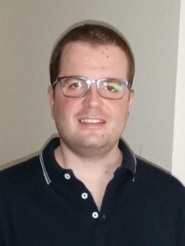
Cristian Moya
Employment is very important
for people with disabilities,
because they improve our quality of life
and we feel more fulfilled.

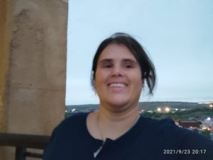
Patricia Gasco
Because I believe that we have
every right to work
because we are citizens
like everyone else.

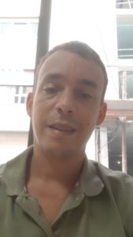
Pablo Buhigas
It is important because we have
the same rights as people
to work in any job,
as all people with disabilities
and without disabilities.

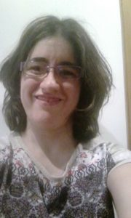
Vanesa Alonso
Because in this way we can have a
more independent life in the future.
The right to employment
is a right included
in the UN Convention
for people with disabilities.

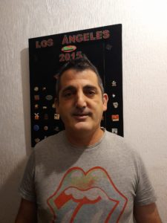
Eduardo Gimeno
Because it gives you stability,
it fulfills you as a person,
you feel more useful and if you are
lucky enough to have good companionship,
you cannot ask for more.

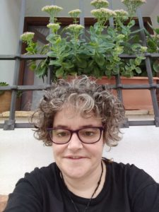
Ana Martinez
It is important to be able
to access a job
and to be valued in the society.

Stories originally published by Plena Inclusion.
http://planetafacil.plenainclusion.org/por-que-es-importante-el-empleo-para-las-personas-con-discapacidad-intelectual-o-del-desarrollo/

The Power of people platform in Spain

More than 500 people
with intellectual or developmental disabilities
have participated in the State Meeting

The meeting was called
The Power of the People.

This meeting was held in Toledo
on Friday, September 24.

It is the first time
people with intellectual disabilities
have an organization
of representatives from
all over Spain.

The Queen of Spain welcomed
the founding of the platform.

The Queen said “Power of people platform
will ensure you can unite
common interests to improve life.
Each of you is important."

“We have been silent for many years,
but that is now over.
We are citizens like the rest,
And that is why we want
our rights to be respected
and that we are not be discriminated against.
We also fight
so that our organizations
Give us space to participate
and decide on the issues that affect us.
That is the Power of the People »
Maribel Cáceres.

The platform's website is at elpoderdelaspersonas.org

Why we care about education

Living in your own place.
Having friends.
Making your own choices.
Being good at something.
Belonging.
We all share these goals.
For ourselves.
For others.
Parents for their children.
Teachers for the students.

School is where it starts.
School is very important for children.
It is a place where they learn about things.

School is a place where students
prepare for future work.

School is a place where children
play together and make friends.

We need schools where
all children can be together.
Because they learn to work
and to be with one another.
To understand and respect each other.
To look beyond differences.

School is a place to learn new skills.
Students can learn how to look for answers.
Students can find out what they are good at.

We need schools where
teachers give the right support.
Where teachers find ways
to bring out the best in all students.

A mother says:
“Inclusion at school is good for
my daughter because it
teaches her new skills.
She can deal with hard problems
while being with other students”.

There is progress

Inclusion Europe worked a lot
to make education of children
with disabilities a reality.

Some progress was made.
Some children with intellectual disabilities
go to school with children without disabilities.

More and more people know
inclusive education is good.
All children have the right
to get a good education.

It’s not enough

But there are still many
children that are not going to school.
Children and students
with intellectual disabilities
have the right to learn together.

Separation of children with
and without disabilities in schools is bad.
It breaks relations between children.
It limits future job possibilities.
It makes it more difficult
for families and society afterwards.
But the world of education is changing!

What we should do

Separated education
should be in the past.
There are a few things
that we should do.
We should promote
and make sure that
all the students are
in the same classroom.

That education methods
are adapted to every student.
That teachers have enough skills,
time and tools.

The government should spend
enough money on inclusive
education to make it accessible.

We must make sure education
continues at every age.
Online education must also
be possible and accessible.
People with intellectual disabilities
should be able to teach
and do research.

Everyone should be heard:
- People with intellectual disabilities
- Disability organisations
- Parents
- People who went in inclusive education
- Other victims of exclusion
- Teachers

Some words should not be used:
The word “special” should not be used
for people with intellectual disabilities.
The word “alternative” should not
be used for education
because education should be “inclusive”.

Make sure we do not get confused:
- Integration is not inclusion
- It is not inclusive education
if there is no accommodation,
no support and no full participation

