

**Permission to use my video**

Explanations for the words in bold are at the end of this text.

I give permission to **Inclusion Europe**to use the video I sent them.

I give permission to Inclusion Europe   
to use this video to make their own video.

Inclusion Europe’s video will be posted on their website,  
and also on their different **social media** channels.

Inclusion Europe will talk about the video in its publications.

Anyone will be able to see the video.

I understand that:

* Inclusion Europe will store the video files and the final video.  
    
  They will be stored respecting the law.
* Inclusion Europe will be the owner of the video files  
  and the final video.

This is called copyright.

* I can ask Inclusion Europe to tell me where my files are stored.
* I can ask Inclusion Europe to delete my files.

Inclusion Europe will do this.

But it cannot delete any part of the video already published.

If I want to complain about something,  
I can write to Inclusion Europe at

Inclusion Europe

55, Rue d’Arlon

1000 Brussels

Belgium

Or [secretariat@inclusion-europe.org](mailto:secretariat@inclusion-europe.org).

Do you agree with everything that is written above?

Then please put here your

___________________________________ ________________________

First and last name Country

___________________ ____________________________________

Date Signature

**Explanations:**

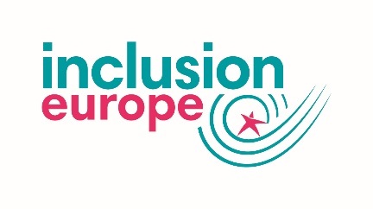**Inclusion Europe**   
  
Inclusion Europe is an organisation for people   
with intellectual disabilities and their families.

Inclusion Europe fights for their equal rights   
and inclusion in Europe.

It also wants to make a difference to the laws in Europe.

It started in 1988.

It has 75 members in 39 European countries.

It is based in Brussels in Belgium.

cid:image014.jpg@01D450D6.C104D5D0**Social Media**Social media is made up of websites and apps   
that let you create and share content.  
  
For example, photos, videos and information.

Apps is short for applications.   
  
These are tools that let you use social media   
on a mobile phone or tablet.